

Student Name: KABURU EVANS MUTHOMI
Admission Number: BSCCS/2024/62210
Course/Class: Bachelors of Science in Computer Science
Unit Code: BIT4138
Unit Name: Advanced Cryptography
Lecturer Name: Michael Nyoro
Semester/Academic Year: May/August 2026

GitHub Repository Link:
https://github.com/mthomikaburu

Contents
Hashing and Password Security 2
Implementation of Secure Hash Functions and Authentication 2
Fig 1: SHA-256 Hash Generation 2
Fig 2: Password Hashing System 3
Fig 3: Login Authentication Workflow 4
Fig 4: Hash Verification Results 5
Fig 5: Password Security Testing 6
Student Reflection 6

Week 6

Hashing and Password Security

Implementation of Secure Hash Functions and Authentication

Fig 1: SHA-256 Hash Generation
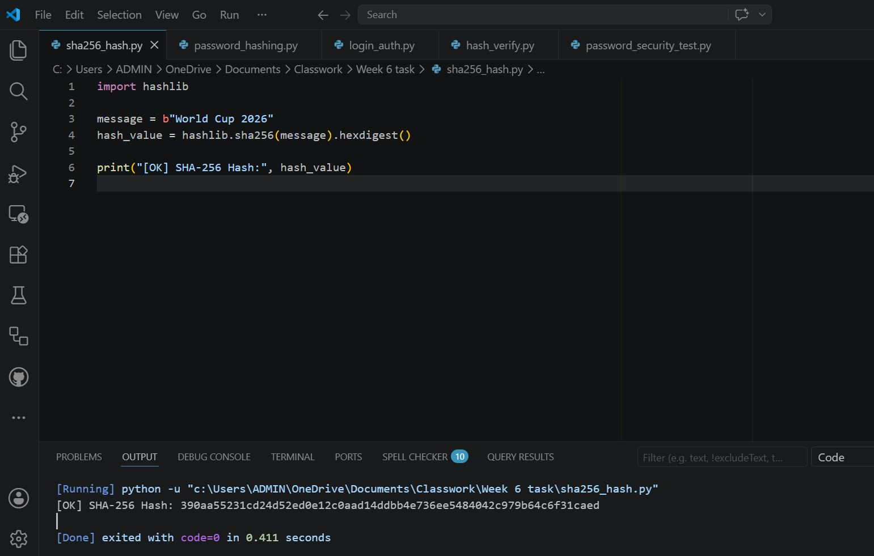

Fig 2: Password Hashing System

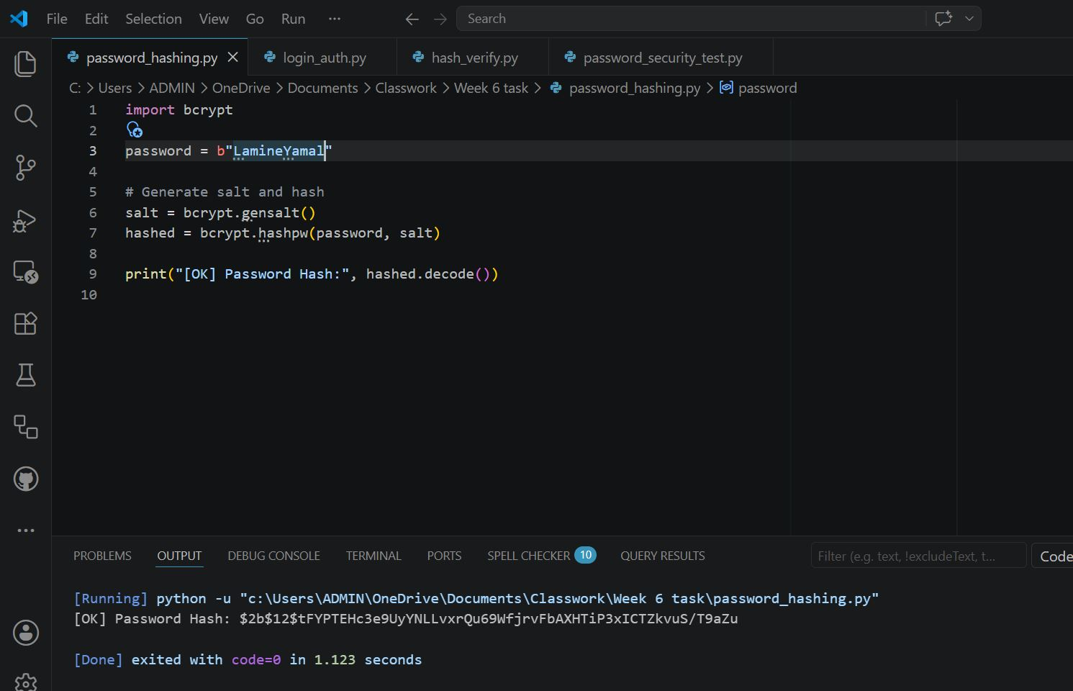

Fig 3: Login Authentication Workflow

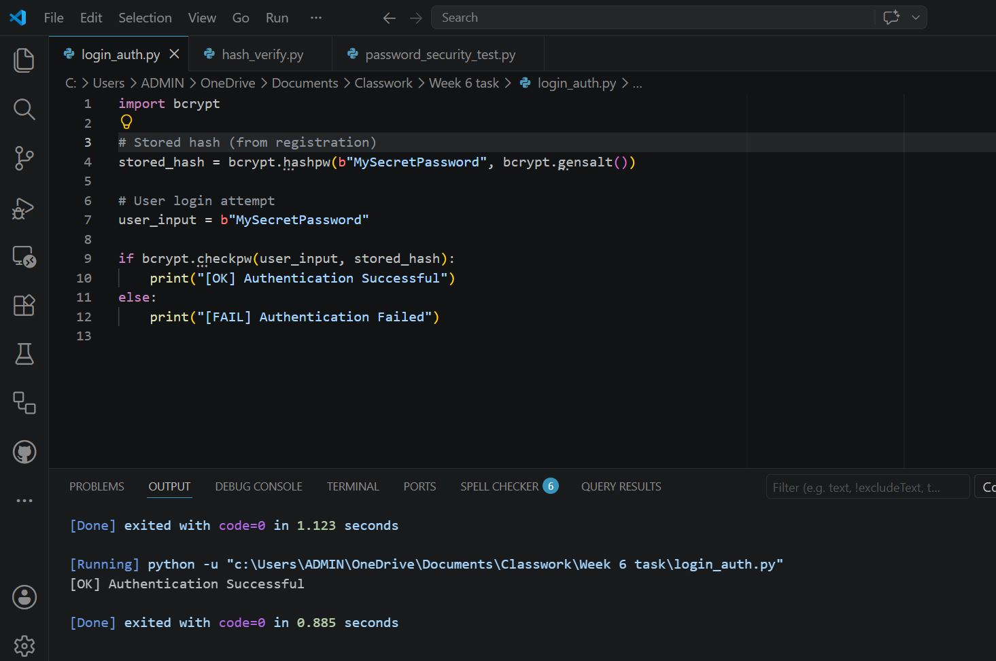

Fig 4: Hash Verification Results

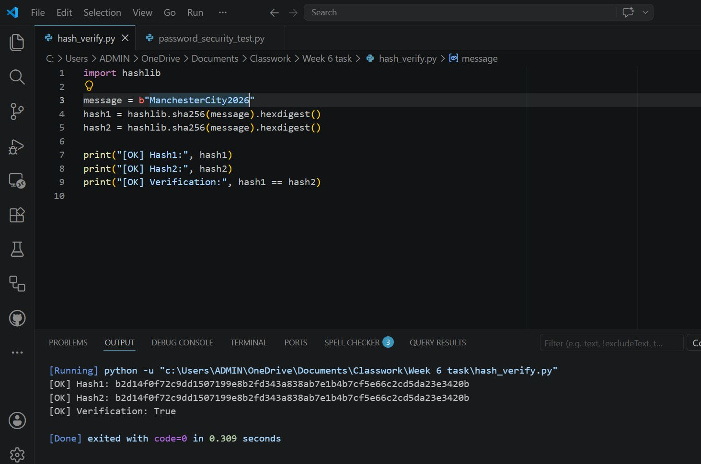

Fig 5: Password Security Testing

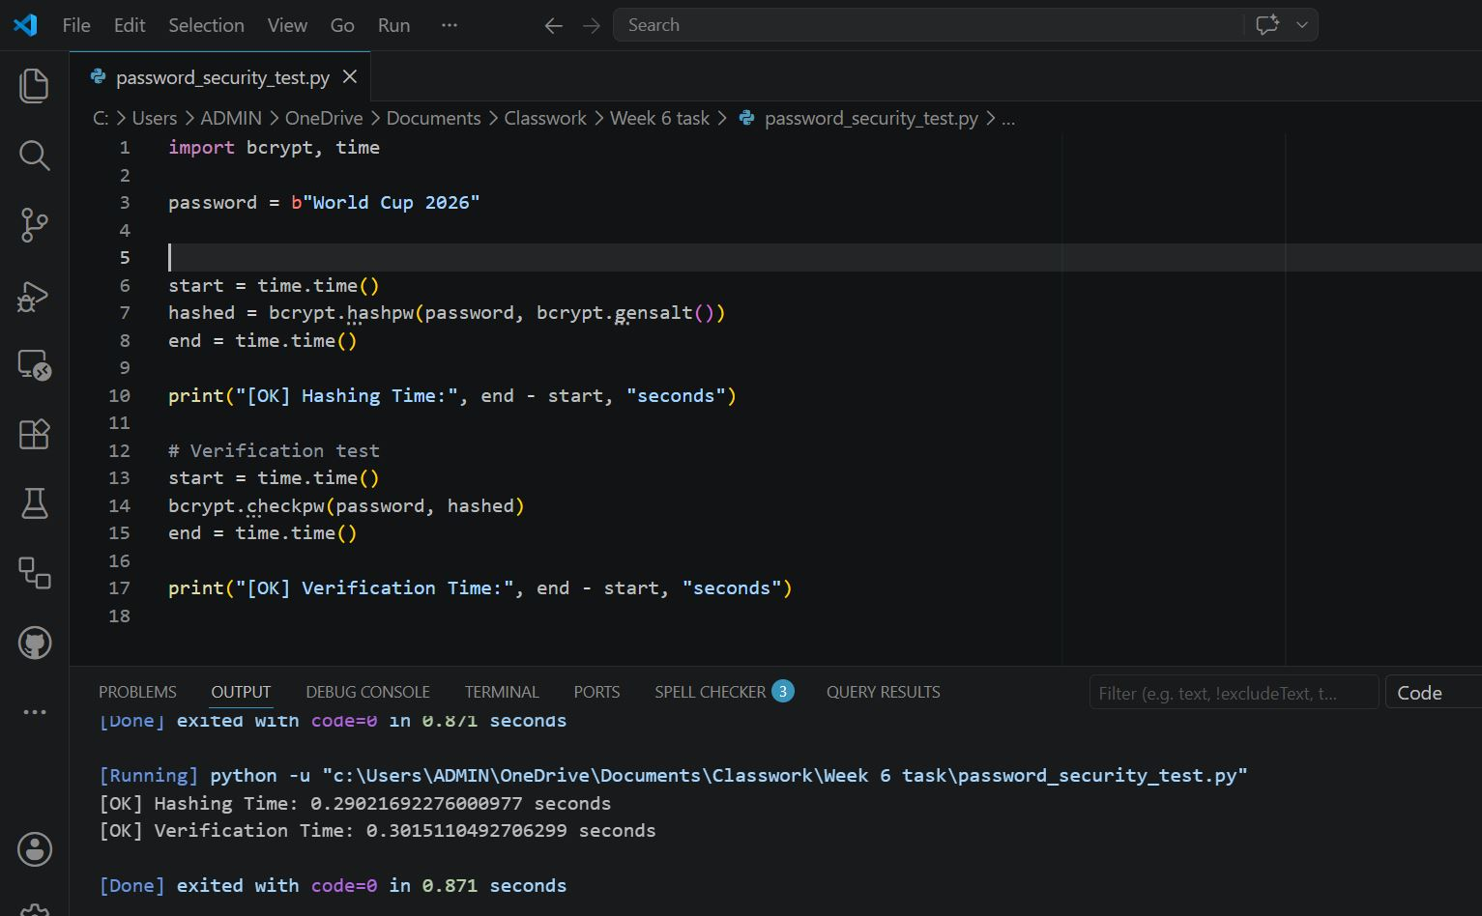

Student Reflection
Hashing secures passwords by producing irreversible digests. Unlike encryption, no decryption exists. Public authentication relies on verifying input against stored hashes. RSA uses keys, while hashing ensures password safety. Testing confirmed SHA-256 generation, authentication workflow, and secure verification.

